|  |  |  |  |
| --- | --- | --- | --- |
| **Lyng Primary School Knowledge Organiser** | | | |
| **Topic:** | **Are all settlements the same?** | Year 4  Battles, beliefs and buildings | Autumn |

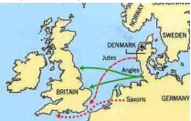

|  |  |
| --- | --- |
| **What Step On and Goldilocks words will I use?** | |
| **Spelling** | **Definition** |
| Settlements | A settlement is a place where people have [come](https://www.collinsdictionary.com/dictionary/english/come) to [live](https://www.collinsdictionary.com/dictionary/english/live) and have [built](https://www.collinsdictionary.com/dictionary/english/build) [homes](https://www.collinsdictionary.com/dictionary/english/home). |
| County | A county is a region of [Britain](https://www.collinsdictionary.com/dictionary/english/britain), [Ireland](https://www.collinsdictionary.com/dictionary/english/ireland), or the USA which has its own local government. |
| Region | A region is a large area of land that is different from other areas of land |
| Invaders | Invaders are soldiers who are [invading](https://www.collinsdictionary.com/dictionary/english/invade) a country. |
| Invasion | If there is an invasion of a country, a [foreign](https://www.collinsdictionary.com/dictionary/english/foreign) [army](https://www.collinsdictionary.com/dictionary/english/army) [enters](https://www.collinsdictionary.com/dictionary/english/enter) it by force. |
| Etymology | Etymology is the study of the [origins](https://www.collinsdictionary.com/dictionary/english/origin) and [historical](https://www.collinsdictionary.com/dictionary/english/historical) development of words. |
| Legacy | A legacy of an event or period of [history](https://www.collinsdictionary.com/dictionary/english/history) is something which is a [direct](https://www.collinsdictionary.com/dictionary/english/direct) result of it and which [continues](https://www.collinsdictionary.com/dictionary/english/continue) to [exist](https://www.collinsdictionary.com/dictionary/english/exist) after it is over. |
| Location | A location is the place where something [happens](https://www.collinsdictionary.com/dictionary/english/happen) or is [situated](https://www.collinsdictionary.com/dictionary/english/situate). |

**Background information for parents and teachers**

The Viking Age in Britain began about 1,200 years ago in the 9th Century AD and lasted for just over 200 years. The Vikings came across the North Sea, just as the Anglo-Saxons had done 400 years earlier. In time, like the Anglo-Saxons, the Vikings made their home here. This topic focusses on the complex struggle for power between the Anglo-Saxons and the Vikings, which was ultimately ended, in 1066, by the Norman invasion (who were, themselves, descended from Vikings).

|  |
| --- |
| **Geographical study** |
| **Anglo-Saxon legacy in the UK**   * The root words in town names. * Look at maps and locate towns with names * Understand the meanings of different names. * Identify counties and discuss the difference between town and county. |

**Fieldwork Opportunities**

* Create Anglo-Saxon settlement
* Tamworth castle trip

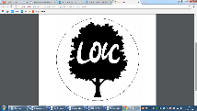

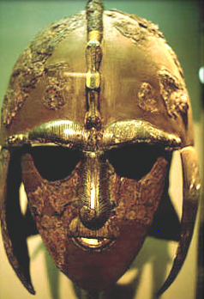

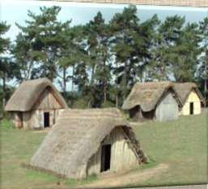

**Significant places**

* Mercia
* Hastings
* East Anglia
* Senlac hill
* Normandy

**Our Storytelling Approach to enhance engagement**

|  |  |  |
| --- | --- | --- |
| **People:**  Anglo-Saxon War-Chiefs. ‘Bretwalda’ ruler of all the Kingdom. | **Place:**  East Anglia – Senlac Hill (Battle of Hastings) | **Problem:**  Should we go to battle? Who should rule? |

**Key facts and locations**

**Map to be studied**

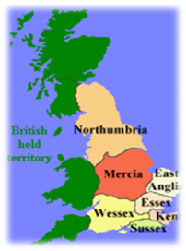

**Agreed Outcome**

A labelled map of the UK with Anglo-Saxon towns and counties.

## The Anglo-Saxons came to England after the Romans left in the year 410. Nobody was really ruling all of England at the time – there were a lot of little kingdoms ruled by Anglo-Saxons that eventually came together as one country. **The Anglo-Saxons are made up of three tribes who came to England from across the North Sea around the middle of the 5th century – the Angles, Saxons and Jutes.**

Some of our modern English words are from the Anglo-Saxons, such as the days of the week, we can see this in see this in place names throughout England.

Anglo-Saxons lived in small villages near rivers, forests and other important resources that gave them everything they needed to care for farm animals, grow crops and make things to sell.  
  
We know how the Anglo Saxons lived because archaeologists have found old settlements and excavated artefacts like belt buckles, swords, bowls and even children’s toys.

Sutton Hoo is near the town of Woodbridge in Suffolk, England. The site was excavated in the 1930s and it has r revealed some incredibly important finds and helped to further our knowledge of the Anglo-Saxons in Britain. T The items discovered at Sutton Hoo almost certainly date from the 7th century. One of the items discovered in a a burial chamber was an entire ship and its contents. The ship almost certainly belonged to an important warrior or leader and it was hauled up the River Deben to the burial site.

|  |  |  |  |
| --- | --- | --- | --- |
| **Lyng Primary School Knowledge Organiser** | | | |
| **Topic:** | **Britain’s settlement by Anglo-Saxons and Scots.** | Year 4  *Battles, Beliefs and Buildings* | Autumn |

|  |  |  |
| --- | --- | --- |
| 5. What Anglo-Saxon Kingdom is Birmingham located within? | **S** | **E** |
| 1. Mercia |  |  |
| 1. Kent |  |  |
| 1. Essex |  |  |

|  |  |  |
| --- | --- | --- |
| 6. What does ‘Essex’ mean? | **S** | **E** |
| 1. East England |  |  |
| 1. East Midlands |  |  |
| 1. East Saxons |  |  |

|  |  |  |
| --- | --- | --- |
| 7. What geographical location did Anglo-Saxons choose to live by? | **S** | **E** |
| ______________________________________ ______________________________________ ______________________________________ |  |  |

|  |  |  |
| --- | --- | --- |
| 8. What were Anglo-Saxon roofs made from? | **S** | **E** |
| 1. Hay |  |  |
| 1. Brick |  |  |
| 1. Tiles |  |  |

|  |  |  |
| --- | --- | --- |
| 1. Which continent did the Anglo-Saxon tribes come from? | **S** | **E** |
| 1. Africa |  |  |
| 1. Asia |  |  |
| 1. Europe |  |  |

|  |  |  |
| --- | --- | --- |
| 2. What are the names of the Seven Kingdoms during the Anglo-Saxon reign? | **S** | **E** |
| ______________________________________ ______________________________________ ______________________________________ |  |  |

|  |  |  |
| --- | --- | --- |
| 3. ‘Ham’ means village. True or false? | **S** | **E** |
| ______________________________________ |  |  |

|  |  |  |
| --- | --- | --- |
| 4. What is a settlement? | **S** | **E** |
| a) A place where people live. |  |  |
| b) A castle on a hill. |  |  |
| c) A tent in a field. |  |  |